TRABAJO 1: PUERTAS LÓGICAS

|  |  |  |  |
| --- | --- | --- | --- |
| A | B | C | S |
| 0 | 0 | 0 | 1 |
| 0 | 0 | 1 | 1 |
| 0 | 1 | 0 | 1 |
| 0 | 1 | 1 | 1 |
| 1 | 0 | 0 | 1 |
| 1 | 0 | 1 | 1 |
| 1 | 1 | 0 | 1 |
| 1 | 1 | 1 | 1 |

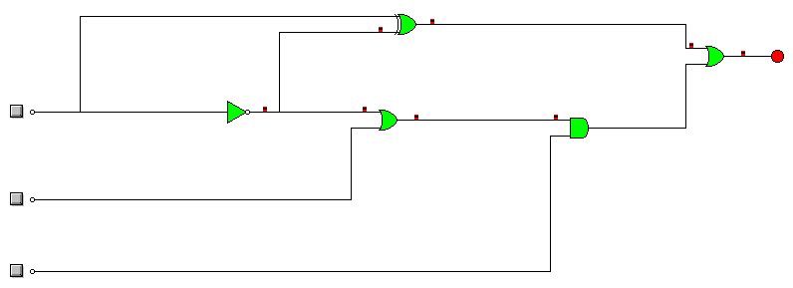

Ecuación: a’·(a’+b)+(a’+b)’+(a’+b)·c